**ECE 430**

**Laura and Joshua**

**Lab 7**

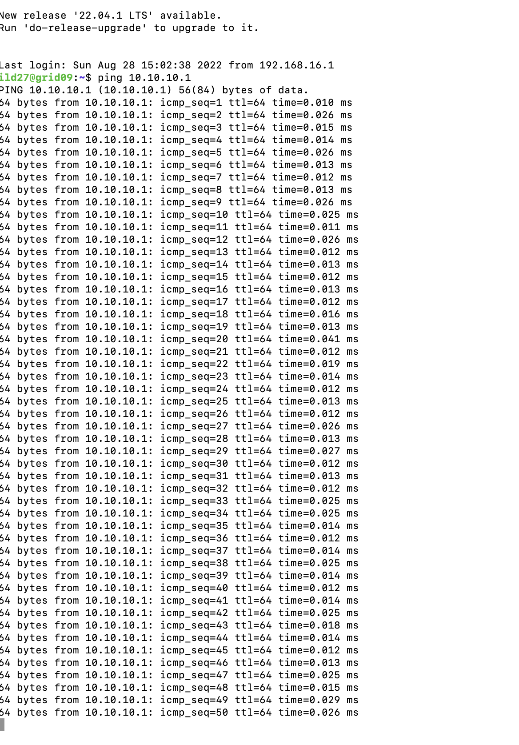

**Figure 1:** ping working on the transmitter

**Figure 2:** mgen Tx and Rx

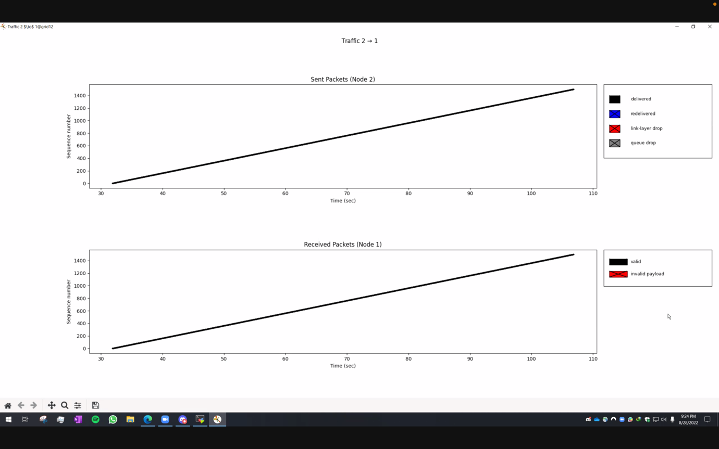

**Figure 3:** plot-traffic (without --mgen-seq)

**Figure 4:** plot-traffic (with --mgen-seq) showing individual packets

Dragonradio is using the FIFO queuing method by default. That is why, the mgen sequence number increases as a function of time.

**LIFO queue**

**Figure 5:** overall plot of mgen sequence number vs. time

**Figure 6:** overall plot of mgen sequence number vs. time showing individual packets, going from low to high and then from high to low.

From the middle (t=50 sec), it is following a LIFO transmission, where the last packet is being displayed first. That is why, we see a linearly decreasing plot (opposite to that of FIFO). However, for the first 50 seconds, it is acting as a FIFO.

Even when we zoom into individual packets, this can be seen for t > 50seconds.

**Tail drop queue**

**Figure 7:** overall plot of mgen sequence number vs. time for 5000

**Figure 8:** Zoomed in plot of mgen sequence number vs. time for 5000

**Figure 9:** Packets view for plot of mgen sequence number vs. time for 5000

**Figure 10:** Plot of mgen sequence number vs. time for 5001

Compared to RED, taildrop seem to be a fairer queuing method as all packets in the bursty transmission (5001) is getting through, and very less queue drops can be seen. However, it should be noted that there are some queue drops in the 5000 line.

**RED queue**

**Figure 11:** Overall plot of mgen sequence number vs. time for 5000

**Figure 12:** Zoomed in plot of mgen sequence number vs. time for 5000

**Figure 13:** Packet view for plot of mgen sequence number vs. time for 5000

**Figure 14:** Plot of mgen sequence number vs. time for 5001

It can be seen that the RED algorithm is not fair for the bursty transmission as there are a lot of queue drops in this. So, Tail drop is better for this scenario.